**Test Management Questions**

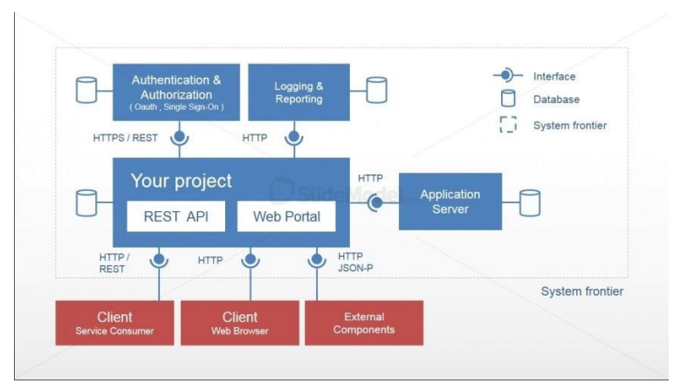

1.1-Which will be essential points of your strategy?  
-It is essential to define a clear scope and develop a detailed roadmap. Effective communication and collaboration with stakeholders and team members are crucial, and clear communication channels should be established. Prioritize tasks based on their criticality and include milestones in the project plan. Monitor progress against the plan and have a clear identification of any issues that arise, then apply hotfixes and adjust the plan accordingly. Finally, review and evaluate each milestone to ensure the project is on track and the objectives are met.

1.2-which will be the main challenges for testing in this project?

-**Environment setup**: setting up the testing environment on AWS can be challenging task. We need to ensure all the dependencies, configurations and settings are correctly configured before start.  
-**Security**: Security vulnerabilities can be challenging and we need to ensure that the application is secure and follows best practices for security.

**-Integration**: As several services call each we need to ensure that the application works correctly when the service are combined [E2E testing, API testing and CI/CD]

**-Monitoring and logging**: we need to ensure that logs and metrics are collected and analyzed to identify any issues in the application. We can use external tool like Data dog or splunk.  
  
1.3-How would you approach the test automation strategy?  
-**Evaluate the application**: we should identify the most critical functionality in our app the most critical is the APIS as our partner access our catalogue from Rest API.  
-**Choose the right Tools:** In our system, we should use tools that are easy to integrate into the existing development. Since developers are using JS, we can use Cypress or Playwright for automation both web and APIS. For performance testing, we can use BlazeMeter, which has a cloud-based architecture that can scale up or down depending on testing needs, eliminating worries about infrastructure limitations. BlazeMeter can integrate with AWS Code Pipeline and Azure DevOps Pipeline, making it easy to integrate with CI/CD. Additionally, it supports HTTPS and provides real-time reporting, enabling faster identification and resolution of issues.  
**Define a clear Scope:** identifying the testing scenarios that can be automated, including smoke testing, regression testing, performance testing and security testing.

**Develop test cases**: test cases should be suitable to automated, well defined High priority test cases should be automated first.  
**Creation an execution plan**: we should add the outline for the automation process included the data to be used and expected results.  
**Implement and monitor automation**: Implement the script and integrate it with the system to test it E2E. Update and maintain the test scripts to be aligned with any changes to the system so that issues and failures can be identified smoothly in an early stage.  
1.4-How would you approach the integration of automated testes into the project CI/CD?  
- We can use Azure to integrate it with Cypress , BlazeMeter and Maven. For the report, we can integrate the azure with JUnit to get a clear visions shown in the below figure1.1. After each code change, test cases run automatically and give us a clear report with a chart. This will help us maintain the quality and reliability of the automated tests. We can also release new features smoothly into production stage in automated way after checking and running all our test cases.

[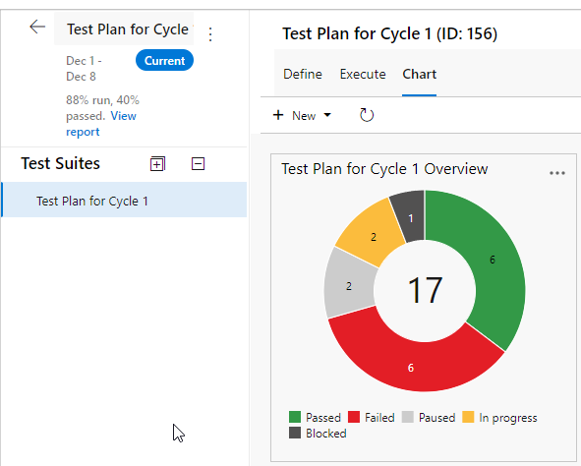](https://www.youtube.com/watch?v=P3vVtUKrw0A&ab_channel=SagarS)  
 Figure1.1[**Azure’s Report**]

**Block 2:**

2.1 Which methodologies would recommend for this project development?  
-Agile-Extreme programming

2.2-Why?

- Since we have limited time, XP emphasizes communication, simplicity, feedback, and rapid iteration. XP includes several practices that help us to deliver quickly and with high quality, such as TDD and CI (Continuous Integration). XP also prioritizes the customer by placing them at the center of the development process. Practices like Pair Programming and Code Review increase the quality of the product, ensuring that we meet the customer's needs. We will have fast feedback and share our understanding and have code ownership.

[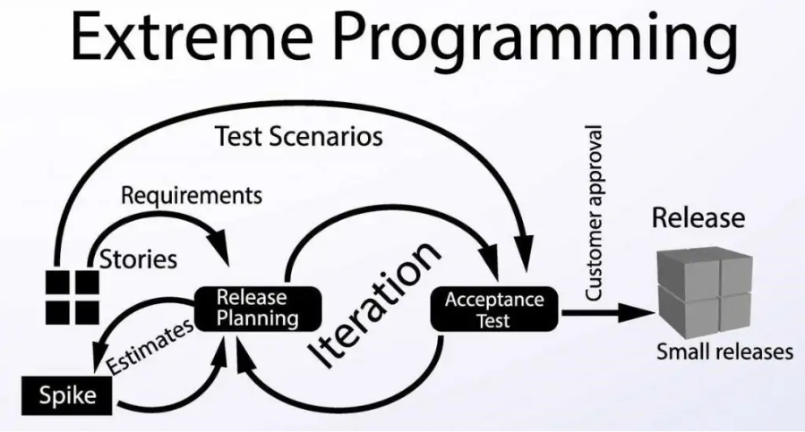](https://www.digite.com/agile/extreme-programming-xp/)

Figure2.1[**XP Methodology**]

**Block 3:**

3.1 How would you configure the test team for this project?

- squads -> first one UI and performance second one APIS and security third integration and security   
3.2-Which skills would you consider essential for your team member to have?

3.2.1-First Squad -> For the First Squad, The candidate should be detailed oriented, strong technical skills in JavaScript and familiar with testing tools such as playwright, cypress or selenium, basic knowledge of UI design principles, good communication skills, and good knowledge in performance testing. They should also be familiar with performance testing tools such as Blazemeter, JMeter, or Load Runner and have a good understanding of performance metrics such as response time, throughput, and resource utilization. Strong analytical skills are also required.  
3.2.2-Second Squad->API tester role should have a good understanding of API concepts, including request and response formats, and be familiar with API testing tools such as Postman, SoapUI, and Swagger. They should have a strong command of programming languages, such as JavaScript. Additionally, they should possess strong knowledge of testing techniques, such as boundary value analysis, equivalence partitioning, and negative testing, as well as security testing concepts, such as authentication, authorization, and encryption. Good understanding for code analysis and review.

3.2.3-Third squad->tester should have a strong integration concept such as DB connection, API interaction .an experience in integration tool like Kafka, Apache..Etc. Programming language preferred JS.Strong communication skills. Strong knowledge in Network security, cloud security and application security.

3.3-Which mindset and attitudes would look for in your team?  
-Good communication skills and fast delivery with high quality are important attributes. It is also important to have a fast and flexible coping mechanism to adapt to changes beside the tech skills.

**Block4**:

4.1How would you identify the test scenarios or test cases needed?

-Analyze the requirements: If the SRS document exists, analyze it to determine the scope of the testing effort and identify the features and functionalities to be tested. Identify test objectives: Determine the goals of the testing effort and estimate the effort required for all testing activities. Determine test data: Identify the test data needed, such as input, expected output, and preconditions, and prioritize the test data. Write and execute test cases: Based on the identified test scenarios and test data, write and execute test cases that cover all possible combinations of inputs, actions, and outcomes Report defects: If any defects are found during testing, report them and track their progress until they are resolved. Perform regression testing: After resolving the defects, perform regression testing to ensure that the changes do not introduce new defects.  
4.2-How would you keep traceability between the test scenarios/cases and requirements?  
- We can use Reqtify tool we should update tractability matrix with any changes in test cases or document. Each identifier in tractability matrix should be unique.  
4.3-How would you split the testing responsibilities between developers and testers?  
-Developers should write unit test and work closely with tester   
**Block 5:**5.1-Which tools would you use for test management?

-Azure Devops  
5.2-Which tools would you use for performance testing?  
-Blazemeter  
5.3-Which tools/framework would you use for AP testing and API automation?  
-Swagger for manual  
-playwright for automation  
5.4-Which tool /framework would you use for FE testing and FE automation?  
-Playwright  
5.5-which other tools would you use?  
-Reqtify for the traceability Matrix, Ansible to automate the repetitive task,Kafka.